Chapter 10, Solution 31.

Use mesh analysis to determine current I_{o} in the circuit of Fig. 10.79 below.

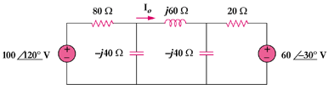

Figure 10.79
For Prob. 10.31.

Solution

Consider the network shown below.

I_{o}

I₂

j60

20

80
+

100120 V

60-30 V
+

-j40

I₃

I₁

-j40

For loop 1,
(1)
For loop 2,
(2)

For loop 3,
(3)
From (2),

Substituting this equation into (3),
(4)

From (1) and (4),

2.17961.44 A

